Low Level Design (Add To Cart module)

Project Code | Team1
Project Name | E-Commerce (Online Shopping)

Prepared/Modified by | Role | Date of Preparation
Mrunalee Kothari | Software Engineer | 16/12/2013
Reviewed by | Role | Date of Review
Amit Agarwal | Software Engineer | 17/12/2013
Approved by | Role | Date of Approval
Uma M Ponniamman | Training Manager
Circulation List | amit.agarwal@igate.com, mrunalee.kothari@igate.com, keerthi.parthasarathy@igate.com, nidhi.shetty@igate.com, nikeeta.menon@igate.com, shrikant.sutar@igate.com, bhagyashree.vedpathak@igate.com | Version Number of the template:1.0
Version Number | 1.4

Table of Contents

1. Description Of The Unit 3
2. References 4
3. Dependencies / Assumptions 5
4. Class Diagrams 6
5. Sequence Diagrams 7
6. Design Components 8
6.1 List Of UI Components 8
6.2 List Of Design Classes 8
7. Re-Usable Routines/Components 9
8. Messages 10
9. Configuration Files 11
10. Crud Matrix Table 12
11. Data Mapping Matrix 13
12. Action Flow Matrix 14
13. Stored Procedures 15
14. Program Specification / Pseudo Code 16
REVISION HISTORY OF THE WORK PRODUCT 17

Description Of The Unit

The Add to cart module is basically used by the customer of the system, to add an item to the cart. It requires a pre-requisite that the customer should be logged into the system.

On clicking the Add to cart button on the viewItem page, the customer will be navigated to the addToCart page where he can view the cart. There is a link provided on the addToCart page named as ‘Continue to shop’. On clicking this link customer is navigated to the homepage where the customer is provided with the provision of selecting more items and adding it to the cart. Further, on the addToCart page there is a delete button. On clicking the Delete button he/she can remove the item from the cart. Customer can place the order once he/she is finished with shopping.

References

Reference | Description
Repository reference | https://IGTEBLRSVNTNG.igatecorp.com/svn/oct3_Team1
Class Diagram | /Project Documents/Design Documents/HLD/Class Diagrams
URS | /Project Documents/Requirements/Case Study/Ecommerce-grp1 and grp3.doc
UTP | /Project Documents/Test Plan /UTP /Test Cases/AddToCart/ UTP_AddToCartModule.xls
DB Design | NA

Dependencies / Assumptions

Dependencies:
Add to cart module depends on the Login module in such a way that, the customer is able to add an item only when he is logged in.
If the customer is not logged in then he/she will be asked to login.

Assumptions:
Customer details are stored in a database.

Class Diagrams

Class Diagram

Sequence Diagrams

Sequence Diagram
NA

Design Components

List Of UI Components
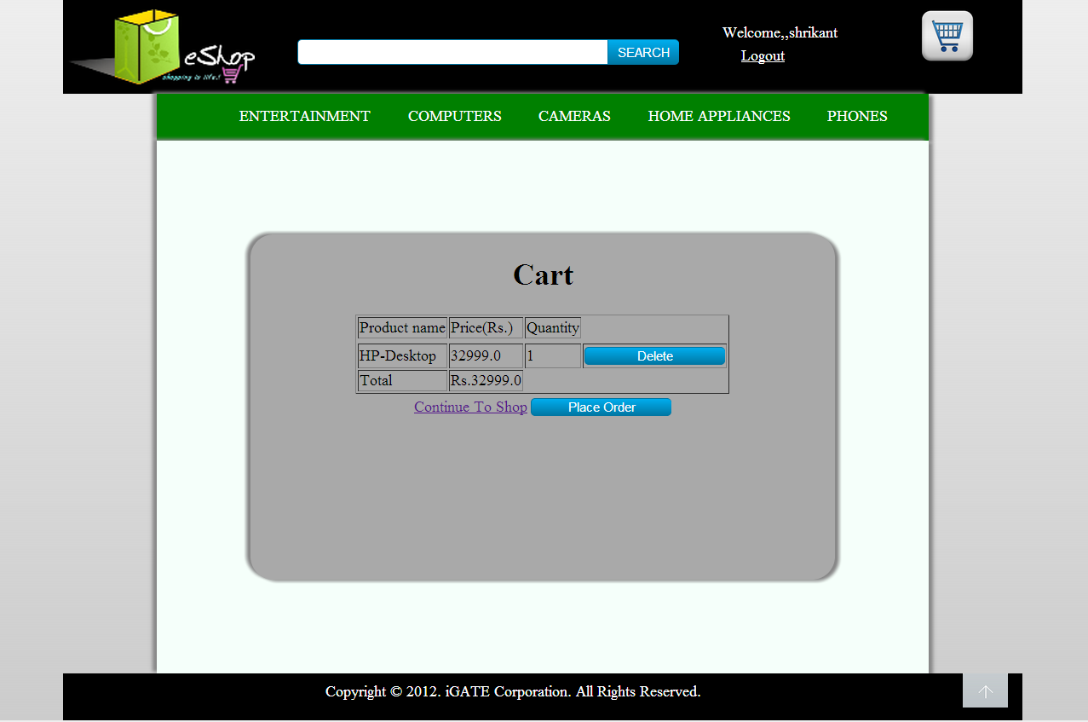

List Of Design Classes

Sr. No. | LLD Name | Class Name | Method Name | Method Description
1 | Add to cart Module | Product,  ProductImage | Appropriate getters and setters methods | Getters retrieve the property values and setters set the property values
2 | Add to cart Module | EshopController | proceedToAddToCartPage(@ModelAttribute(value="product") Product product, @RequestParam(value="userQuantity") String userQuantity,Model model):String  deleteFromCart(@RequestParam(value="productId") String productId,Model model):String  gotoAddToCartPage(Model model):String  prepareHomePage(Model model):String | Sets the model attribute. Adds the selected item into the cart and navigate to Eshop_Customer_AddToCart page.  Delete the selected item into the cart and navigate to the same page.  Navigate to Cart page whenever customer clicks on to the cart icon.  On clicking the “Continue to shop link”, this method of controller is called that retrieves data like categories and products to be displayed on the home screen.

Re-Usable Routines/Components

Re-Usable Routines/Components

- CSS files
- Logger properties files
- Pagination concept

8. MESSAGES

#. | Type | Message Text
M1 | Information | No items in the cart.

9. CONFIGURATION Files

File Name | Path | Description
Web.xml | /Development/Source | To configure the bean properties.
Dispatcher-servlet.xml | /Development/Source | To configure the request mapping and view resolver.
Eshop_logger.properties | /Development/Source | To configure the logger.

Crud Matrix Table

# | Table Name | Create | Read | Update | Delete
NA | NA | NA | NA | NA | NA

Data Mapping Matrix

Sr. No. | Screen Label | Field Source | Field Type | Data Type | Max Length | Data Flow | Mandatory
1 | Continue to shop | NA | Link | NA | NA | UI | NA
13 | DELETE | NA | Button | NA | NA | UI | NA
14 | PLACE ORDER | NA | Button | NA | NA | UI | NA

Legend
D → UI (Database to User Interface)
UI → D (User Interface to Database)
UI (User Interface Only)

Action Flow Matrix

Sr. No. | Action | Description | Process
1 | On click of Continue to shop link | Allows the customer to add more items in the cart. | The customer is navigated to the homepage where he can view all the products and add the product to the cart.
2 | On click of Delete Button | Deletes the item from the list. | The respective item from the cart is deleted and the control is navigated to the same page (the cart is refreshed).
3 | On click of Place Order Button | The customer can view the order placed by him/her and also confirm order. | The customer is navigated to the place order page.

Stored Procedures
# | Stored Procedure Name  (with Description) | Input/Out Parameters | Type | Size
1. | NA | NA | NA | NA

Program Specification / Pseudo Code

14.1 <ACTION: AddToCart_CLICK>

Pseudo Code:
- Client Side Scripting:
None

- Server Side Scripting:
BEGIN

IF Customer is not logged in
Navigate to Eshop_User_Login.

IF Customer is logged in

Call proceedToAddToCartPage(@ModelAttribute(value="product") Product product, @RequestParam(value="userQuantity") String userQuantity,Model model):String in Controller class

Navigate to Eshop_Customer_AddToCart page.

IF the cart is empty
Print message M1

END

14.2 <ACTION: Delete_CLICK>
Pseudo Code:
- Client Side Scripting:
None

- Server Side Scripting:
BEGIN
Call deleteItemFromCart (Model model) in Controller class
Delete an item from the list.
Reset the cartList.
Navigate to Eshop_Customer_AddToCart page.
END

14.3 <ACTION: ContinueToShop_CLICK>

Pseudo Code:
- Client Side Scripting:
None

- Server Side Scripting:
BEGIN
Call proceedToHomepage (Model model) in Controller class
Navigate to the Eshop_Customer_HomePage.
END

REVISION HISTORY OF THE WORK PRODUCT

# | Date | Version # | Section Changed | Details of changes made | Approved By
1 | 16/12/2013 | 1.0 | LLD prepared | N/A | Uma M Ponniamman
2 | 17/12/2013 | 1.1 | Reusable components,  Pseudo Code. | Unwanted Reusable components removed.  More specific control flow specified. | Uma M Ponniamman
3 | 17/12/2013 | 1.2 | Designed Classes,  Reusable components,  Reference | The Controller’s name is changed to ‘EshopController’.  Reusable Components added.  File name with relative path is added in the references section. | Uma M Ponniamman
4 | 20/17/2013 | 1.3 | Designed Classes,  Pseudo code | The method names in the designed class table and pseudo code are changed as per the class diagrams. | Uma M Ponniamman
5 | 24/12/2013 | 1.4 | Configuration files,UI Components | Paths of the configuration files is updated and UI components(Screen Shots) added. | Uma M Ponniamman

